
MAMC01812: Software Engineering Methodologies: Report

ASSESSMENT 2
A New CRM Software Development Project for The Warehouse Group
- Introduction
Agile methodologies are a contemporary approach to software development that emphasizes adaptability, collaboration, and continuous improvement. Defined by the Agile Manifesto Agile promotes flexible planning, iterative delivery, and direct stakeholder communication. Instead of rigid, lengthy development cycles, Agile encourages small, manageable increments that provide rapid feedback and faster delivery of usable software.
The growing importance of Agile reflects the demand for reliable yet adaptable systems in competitive digital markets. Its short iterations allow teams to identify issues early, respond quickly to changing requirements, and maintain high software quality. Through continuous testing and feedback, Agile reduces development risk while ensuring that evolving customer and business needs remain central to the project.
The Warehouse Group (TWG), one of New Zealand’s largest retail organizations, continues to modernize its operations through digital transformation. The proposed Customer Relationship Management (CRM) project aims to unify customer data from multiple channels online transactions, loyalty programs, and in-store interactions into one accessible platform. Using Agile principles, TWG’s cross-functional teams can deliver the CRM incrementally, review progress at each stage, and refine features based on real user feedback. This ensures the system remains aligned with both customer expectations and organizational goals.
This report critically analyses the evolution of software-engineering methodologies, focusing on how Agile practices have developed over time and influenced modern software delivery. It then evaluates various methodologies, comparing their advantages, disadvantages, and suitability for TWG’s CRM development. Finally, the Scrum model, an Agile framework built on iterative sprints and continuous feedback will be applied to the, assessing its effectiveness, limitations, and potential improvements supported by academic research and best practices.

- Evolution of Agile Software Development
The evolution of software engineering methodologies marked a transition from informal programming practices to a formal and structured discipline (del Águila et al., 2014). In the 1940s and 1950s, early computing machines such as ENIAC, UNIVAC, and EDSAC were primarily hardware-oriented, requiring programmers to manually input instructions using low-level code. As computing needs expanded, the 1950s and 1960s introduced high-level programming languages such as FORTRAN (1957), COBOL (1959), and ALGOL (1958), which enabled abstraction from hardware and greater focus on logical problem-solving (Priestley, 2017). These developments laid the groundwork for the systematisation of software design and engineering.
During the 1960s, increasing software complexity led to the “Software Crisis,” where many projects were delivered late, over budget, or failed to meet user expectations. To address these issues, the NATO Software Engineering Conferences of 1968 and 1969 formalised software engineering as a recognised discipline that emphasised systematic design, quality assurance, and documentation (Randell, 2018). Out of this initiative emerged the Software Development Life Cycle (SDLC), a framework dividing software creation into distinct phases planning, analysis, design, implementation, testing, and maintenance to improve structure and reliability (Jain & Suman, 2015), addressing challenges raised by the NATO conferences.
Throughout the 1970s and 1980s, plan-driven methodologies such as the Waterfall, V-Model, and Spiral Model became dominant. The Waterfall Model provided a clear, linear sequence of phases that promoted order and traceability (Aroral, 2021). However, it struggled with evolving requirements, often delaying feedback until late in the process (Gumiński et al., 2023).
The V-Model enhanced Waterfall by pairing each development stage with a corresponding testing phase, strengthening validation but maintaining rigidity (Ponce et al., 2021) The Spiral Model, introduced by Boehm in 1986, added iterative cycles and risk assessment to balance planning and adaptability, though it was costly and impractical for small projects (Kute & Thorat, 2014).
By the 1990s, rapid advances in technology and market demands highlighted the limitations of sequential models. Software teams sought more flexible, customer-focused approaches, leading to iterative methods that culminated in the Agile Manifesto (Agile, 2001), Agile emphasised individuals and interactions, working software, customer collaboration, and adaptability over rigid documentation and processes.
Agile frameworks such as Scrum, Kanban, Lean, and Extreme Programming (XP) operationalised these values. Scrum introduced time-boxed sprints, defined roles, and continuous feedback loops to enhance productivity. Kanban visualised workflows to manage capacity and eliminate bottlenecks, while Lean promoted waste reduction and value optimisation (Deshmukh & Srivastava, 2021). XP further advanced software quality through continuous testing, integration, and customer involvement.
The evolution of software engineering from plan-driven SDLC models to Agile has transformed how organizations like The Warehouse Group (TWG) develop digital solutions. Through Agile’s flexible and adaptive approach, TWG can deliver high-quality systems such as its CRM platform more efficiently, improving customer satisfaction and supporting innovation in today’s fast-changing retail environment.

- Evaluation of Software Engineering Methodologies for The Warehouse Group Customer Relationship Management (CRM) System
The Warehouse Group (TWG) is one of the largest retail organizations in the country, is currently using and enhancing a Customer Relationship Management (CRM) System. It is a software solution that centralises customer information to improve communication, service quality, and long-term engagement (Guerola-Navarro et al., 2024) . The benefits of this system are it aims to unify customer interactions across online platforms and physical stores, supporting personalize marketing, enhance loyalty programs and data-driven decision-making (Li et al., 2023). Its complexity arises from the need to manage large volumes of customer data securely, comply with privacy regulations, and provide real-time insights to multiple business units (Palvia et al., 2011). The project’s scope includes integrating the CRM with point-of-sale systems, e-commerce sites, loyalty databases, and analytics tools across multiple retail brands. The project requires multidisciplinary collaboration among software engineers, data analysts, UX designers, marketers, and business managers. Effective coordination is essential due to continuously evolving requirements, diverse stakeholder expectations, and the need for iterative testing to maintain customer-centred system functionality.
A range of Agile methodologies is commonly applied to complex customer focused projects such as CRM development. Scrum is one of the most widely used frameworks, organised around short, time-boxed sprints that deliver incremental product updates (Srivastava et al., 2017). Kanban provides a visual workflow board that helps teams manage tasks, improve flow, and identify bottlenecks (Kirovska & Koceski, 2015). Scrumban combines Scrum’s sprint structure with Kanban’s continuous workflow flexibility, supporting teams that require adaptability. Lean focuses on eliminating waste and delivering only high-value features through continuous improvement (Deshmukh & Srivastava, 2021). Extreme Programming (XP) emphasises technical excellence through practices such as test-driven development, pair programming, and continuous integration. Each methodology applies Agile principles differently, giving organisations multiple options for managing dynamic, collaborative software projects.
Given the scale, data intensity and cross functional nature of TWG’s CRM Project, it is necessary to evaluate how each Agile method supports or limits development effectiveness. Each methodology offers strengths and weaknesses, and their suitability depends on the projects need for coordination, real-time updates and iterative feature delivery.
Scrum provides clear communication across multidisciplinary teams, supports predictable delivery through time-boxed sprints, and enables frequent feedback from marketing, analytics and store operation, which is essential for evolving CRM features. The downside of scrum is that it requires strict discipline and consistent stakeholder involvement. If product owner of key members is unavailable, sprint goals may be delayed or disrupted (Sassa et al., 2023). Scrum is highly suitable for TWGs project because its supports incremental delivery, clear coordination across business units and continuous validation of CRM functionality
On the other hand, Kanban improves visibility through task boards and helps teams identify bottle necks quickly while supporting flexibility prioritization, However, it does not use fixed iterations which can reduce delivery predictability (Lage Junior & Godinho Filho, 2010). Without strict limits, tasks may accumulate and slow progress. This methodology is suitable for TWG CRM project but is better for ongoing maintenance and support rather than initial large-scale development.
Scrumban allows teams to adjust priorities continuously while still benefiting from some sprint structure, which helps when CRM requirements change rapidly. Weak sprint boundaries can reduce planning consistency and introduce coordination challenges for large teams (Alqudah & Razali, 2018). Scrumban is suitable mainly after the core CRM functions are delivered, during phases of optimisation and continuous improvement.
Lean eliminates unnecessary work and ensures focus on high-value CRM features that enhance loyalty and personalisation. Lean has limited structure and may reduce documentation, which is risky for a CRM system requiring strict governance and auditability (Luna et al., 2025). Lean works best as a supporting mindset rather than the primary methodology for TWG’s CRM due to the project’s scale and data compliance requirements.
XP (Extreme Programming) enhances technical quality through continuous testing, pair programming, and refactoring, promoting stable CRM modules. XP requires intensive collaboration, high technical skill, and significant developer time, which may not be feasible for TWG’s diverse teams (Ahmad Dalalah, 2014). XP is useful when integrated with Scrum for improving code quality and automated testing, but it is not suitable as the main methodology for a large enterprise CRM project.
Considering these evaluations, each methodology shows distinct strengths and limitations for TWG’s CRM project. Scrum supports structured, incremental delivery and strong cross-functional coordination, which aligns closely with the evolving nature of CRM development (Sassa et al., 2023). Kanban contributes valuable workflow transparency but lacks the time-boxed discipline needed for major CRM releases (Lage Junior & Godinho Filho, 2010). Scrumban offers flexibility when priorities shift, yet its weaker sprint boundaries reduce planning reliability for a large, data-intensive system (Alqudah & Razali, 2018). Lean helps emphasize high-value CRM features, though its minimal documentation risks compliance and audit challenges (Luna et al., 2025). In contrast, XP’s intensive technical practices are unrealistic for TWG’s multidisciplinary environment (Ahmad Dalalah, 2014). Therefore, while these methodologies each provide useful elements, Scrum remains the most relevant and practical primary approach for the CRM project, supported by selective practices from Kanban, Scrumban, Lean, and XP where appropriate.
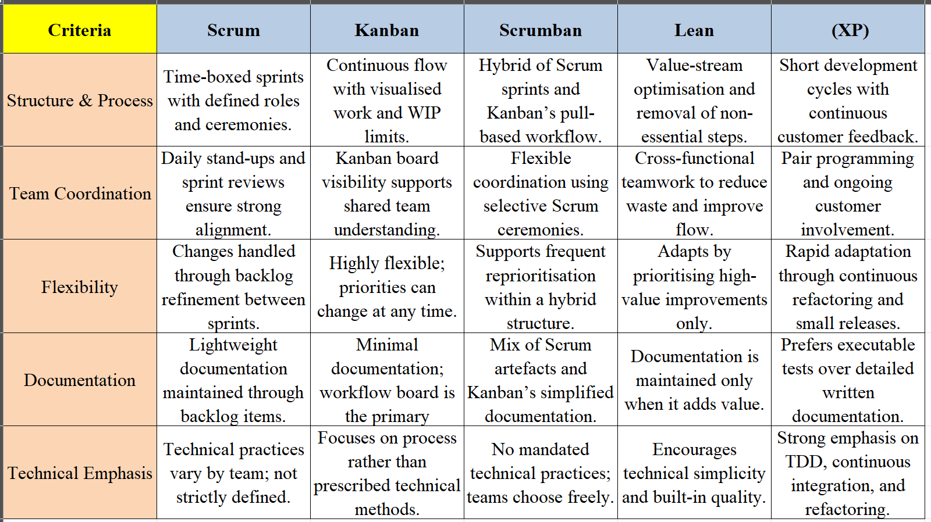
Figure 1: Comparison of Agile Software Development Methodologies
This figure compares five Agile methodologies across structure, coordination, flexibility, documentation, and technical practices.

- Application of Scrum for The Warehouse Group (TWG) CRM Development Project
Scrum is a suitable methodology for TWG’s CRM Project due to its structured sprint cycle. Clear team roles and strong alignment with continuous feedback from multiple business units such as marketing, analytics, customer service and store operations(Sassa et al., 2023). The following section outlines how scrum would be applied to deliver the CRM System effectively and efficiently.
4.1 User Story Collection and Backlogs Developments
The CRM project requires gathering detailed requirements from diverse stakeholders who interact with customers’ data daily. In Scrum, user stories represent customer focused expectations written in simple, value driven terms such as “As a__, “As a ___, I want ___ so that ___” (Amna & Poels, 2022). For TWG, user stories would be collected from: Customer service team for ticketing workflows and customer history access, Marketing and loyalty teams –for segmented campaigns, loyalty point visibility. E-Commerce division for personalization, orders and online interactions. In-store retail operations for integrated POS and customer look-up Data and analytics team for dashboards, insights and secure data access. IT Engineering / Security team for system integration, audit and compliance.
User stories would be gathered through workshops, interviews, shadowing, customer journey mapping and analysis of existing TWG systems (Chang & Shao, 2023). The Product Owner (PO) then organizes all user stories into a product backlog, ensuring each item reflects business value, urgency, dependency and compliance requirements. (e.g., Privacy Act 2020 obligations) (Bass, 2015). Prioritization follows MoSCow or WSJF Weighted Shortest Job First) to ensure that essential CRM functionalities such as unified customer profiles, loyalty point visibility, and transaction history are delivered early (Vijayakumar et al., 2024).
4.2 Sprint Planning
Scrum divides work into fixed-length iterations called sprints, typically 2 weeks for TWG’s CRM team. During the Sprint Planning Meeting, the team selects the highest-priority user stories from the backlog to form the Sprint Backlog. Decisions are based on team velocity from previous sprints, complexity estimated using story points, technical dependencies such as linking CRM to POS before adding advanced analytics, and business deadlines such as preparing CRM features for upcoming sales cycles. A clear Sprint Goal is defined, such as “Deliver customer search and loyalty card linking functionality.” (Vijayakumar et al., 2024).
4.3 Daily Scrum Meetings
Daily 15-minute stand-ups are conducted to maintain momentum and transparency across TWG’s cross-functional teams. Each team member answers what they completed yesterday, what they will work on today and whether there are any blockers (Dubey et al., 2015). Common blockers for TWG might include delays in API access from legacy systems, data quality issues or dependencies from external vendors. The Scrum Master removes these impediments to keep the sprint on track.
4.4 Sprint Execution and Development Workflow
During each sprint, developers, testers, designers and data analysts collaborate closely (Olesen, 2014). Key CRM-specific activities include building user interface components for customer dashboards, integrating APIs with loyalty systems, POS and online shopping platforms, implementing data validation rules to prevent duplicate or inconsistent profiles, conducting automated regression testing and performing security checks for customer data protection. Scrum ensures continuous collaboration between technical and non-technical staff, improving alignment on each increment.
4.5 Sprint Review (Product Demonstration)
At the end of every sprint, the team presents the working CRM features to marketing stakeholders, store operations managers, customer service leads and IT leadership. During these sessions, stakeholders test the new features directly (Heikkilä et al., 2017). Examples include searching customer profiles, checking loyalty history and verifying campaign tagging. These sessions provide real-time feedback. This iterative review reduces the risk of misalignment and ensures features reflect real business use cases.
4.6 Sprint Retrospective
After the Sprint Review, the team meets internally to reflect on what went well, what challenges occurred and what improvements can be made (Mansurali Anifa et al., 2024). For TWG CRM, retrospective outcomes may include increasing automated tests for data validation, improving definition of Done for analytics dashboards, adjusting sprint length during peak retail seasons such as the Christmas period and enhancing collaboration between data analysts and software developers. This continuous improvement cycle strengthens team performance and product quality across the duration of the CRM project.
4.7 Release Planning and Delivery
Scrum delivers value in incremental releases, allowing TWG to deploy components of the CRM progressively instead of waiting for a single large launch (Tripathi et al., 2019). A typical release strategy may include Release 1 focusing on foundational features such as customer profile creation, basic search functionality and loyalty account linking. Release 2 may focus on the integration layer including POS integration, e-commerce transaction history and customer notes or service ticket linking. Release 3 may provide advanced analytics including real-time dashboards, personalised marketing insights and predictive customer behaviour modelling. Release planning ensures each increment is delivered with a Definition of Done (DoD) covering code completion, unit testing, security validation, integration, user testing and documentation (Serre & Poggio, 2010).
4.8 Burndown Charts and Velocity Tracking
Scrum teams use Sprint Burndown Charts to track daily progress against sprint goals. This provides TWG with clear visibility of remaining story points, early detection of delays and predictive insight on whether the sprint will finish on time (Mišković et al., 2024). Velocity, calculated as total story points completed per sprint, helps forecast future sprint capacity and improves planning accuracy for long integrations such as POS to CRM linkages.
4.9 Project Completion and Value Delivery
Using Scrum ensures that the CRM project is delivered with high transparency through continuous stakeholder involvement, early identification of risks such as data quality, integration failures or privacy gaps, incremental delivery of working CRM features, continuous validation of user needs throughout the project and flexibility to adapt to TWG’s changing operational or marketing priorities (Hoda et al., 2011). By the end of the project, TWG receives a robust CRM system built through iterative development, validated through real data and shaped by direct end-user input. Scrum enables the organisation to deliver a customer-centric solution more efficiently while maintaining high quality, compliance and scalability.

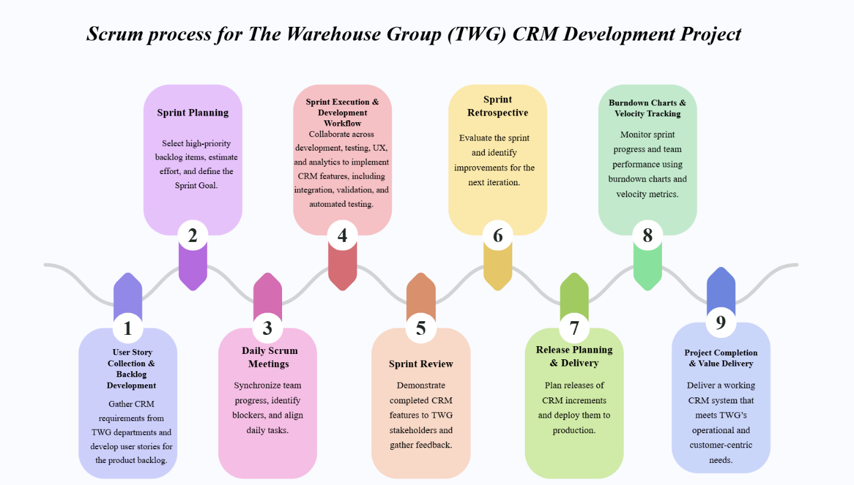
Figure 2: Scrum Based Process for TWG CRM Development
This figure illustrates the nine-step Scrum workflow used for The Warehouse Group’s CRM development project. It shows how the team progresses from gathering user stories and planning sprints through daily coordination, development, reviews, and retrospectives, leading to incremental releases monitored through velocity tracking until final value delivery.

- Summary and conclusion
This report examined how software engineering methodologies have evolved and how these developments inform the effective delivery of The Warehouse Group’s Customer Relationship Management (CRM) system. The review of historical progress highlighted the shift from rigid, plan-driven models such as Waterfall and the V-Model toward more adaptive and collaborative approaches embodied by Agile. This transition reflects the growing need for flexibility, faster feedback cycles and continuous improvement in modern digital environments.
The evaluation of Agile methodologies demonstrated that TWG’s CRM project is characterized by large data volumes, cross-departmental collaboration, privacy requirements and rapidly evolving customer-focused features. Comparing Scrum, Kanban, Scrumban, Lean and Extreme Programming showed that each framework offers valuable practices, but Scrum provides the strongest alignment with TWG’s needs. Scrum’s structured sprints, predictable cadence, clear team roles and emphasis on transparency support the project’s complexity and the organization’s requirement for frequent validation of CRM capabilities.
The application of Scrum illustrated how user stories are collected from diverse TWG stakeholders, how sprints are planned and executed and how continuous feedback is incorporated through reviews and retrospectives. The iterative release strategy allows the organization to deploy CRM capabilities in manageable increments while maintaining compliance, technical quality and customer-centered functionality. Tools such as burndown charts and velocity tracking enhance predictability and support informed decision-making throughout development.
In conclusion, Scrum offers a robust and adaptable methodology for delivering a CRM system that aligns with TWG’s operational goals and evolving digital strategy. Its iterative nature, collaborative structure and focus on working software ensure that the CRM is developed efficiently, validated regularly and improved continuously. By leveraging Scrum, TWG can deliver a scalable and reliable CRM solution that strengthens customer engagement, supports data-driven decision-making and enhances the organization’s competitive position in New Zealand’s retail sector.

- References:
Agile, M. (2001). Manifesto for Agile Software Development. https://agilemanifesto.org/
Ahmad Dalalah. (2014). Extreme Programming: Strengths and Weaknesses. Computer Technology and Application, 5(1). https://doi.org/10.17265/1934-7332/2014.01.003
Alqudah, M., & Razali, R. (2018). An Empirical Study of Scrumban Formation based on the Selection of Scrum and Kanban Practices. International Journal on Advanced Science, Engineering and Information Technology, 8(6), 2315–2322. https://doi.org/10.18517/ijaseit.8.6.6566
Amna, A. R., & Poels, G. (2022). Ambiguity in user stories: A systematic literature review. Information and Software Technology, 145, 106824. https://doi.org/10.1016/j.infsof.2022.106824
Aroral, H. K. (2021). Waterfall Process Operations in the Fast-paced World: Project Management Exploratory Analysis. 6(1).
Bass, J. M. (2015). How product owner teams scale agile methods to large distributed enterprises. Empirical Software Engineering, 20(6), 1525–1557. https://doi.org/10.1007/s10664-014-9322-z
Chang, W.-L., & Shao, Y.-C. (2023). Co-creating User Journey Map – A Systematic Approach to Exploring Users’ Day-to-Day Experience in Participatory Design Workshops. In M. Kurosu & A. Hashizume (Eds.), Human-Computer Interaction (pp. 3–17). Springer Nature Switzerland. https://doi.org/10.1007/978-3-031-35596-7_1
del Águila, I. M., Palma, J., & Túnez, S. (2014). Milestones in Software Engineering and Knowledge Engineering History: A Comparative Review. The Scientific World Journal, 2014(1), 692510. https://doi.org/10.1155/2014/692510
Deshmukh, M., & Srivastava, P. (2021). Literature Review of Lean Methodology and Research Issues for Identifying and Eliminating Waste in Software Development. In A. N. R. Reddy, D. Marla, M. N. Favorskaya, & S. C. Satapathy (Eds.), Intelligent Manufacturing and Energy Sustainability (Vol. 213, pp. 375–388). Springer Singapore. https://doi.org/10.1007/978-981-33-4443-3_36
Dubey, A., Weide, K., Lee, D., Bachan, J., Daley, C., Olofin, S., Taylor, N., Rich, P. M., & Reid, L. B. (2015). Ongoing verification of a multiphysics community code: FLASH. Software: Practice and Experience, 45(2), 233–244. https://doi.org/10.1002/spe.2220
Guerola-Navarro, V., Gil-Gomez, H., Oltra-Badenes, R., & Soto-Acosta, P. (2024). Customer relationship management and its impact on entrepreneurial marketing: A literature review. International Entrepreneurship and Management Journal, 20(2), 507–547. https://doi.org/10.1007/s11365-022-00800-x
Gumiński, A., Dohn, K., & Oloyede, E. (2023). Advantages and disadvantages of traditional and agile methods in software development projects – case study. Scientific Papers of Silesian University of Technology Organization and Management Series, 2023(188). https://doi.org/10.29119/1641-3466.2023.188.11
Heikkilä, V. T., Paasivaara, M., Lasssenius, C., Damian, D., & Engblom, C. (2017). Managing the requirements flow from strategy to release in large-scale agile development: A case study at Ericsson. Empirical Software Engineering, 22(6), 2892–2936. https://doi.org/10.1007/s10664-016-9491-z
Hoda, R., Noble, J., & Marshall, S. (2011). The impact of inadequate customer collaboration on self-organizing Agile teams. Information and Software Technology, 53(5), 521–534. https://doi.org/10.1016/j.infsof.2010.10.009
Jain, R., & Suman, U. (2015). A Systematic Literature Review on Global Software Development Life Cycle. ACM SIGSOFT Software Engineering Notes, 40(2), 1–14. https://doi.org/10.1145/2735399.2735408
Kirovska, N., & Koceski, S. (2015). Usage of Kanban methodology at software development teams. Journal of Applied Economics and Business, 3(3), 25–34.
Kute, S. S., & Thorat, S. D. (2014). A Review on Various Software Development Life Cycle (SDLC) Models. 3(7).
Lage Junior, M., & Godinho Filho, M. (2010). Variations of the kanban system: Literature review and classification. International Journal of Production Economics, 125(1), 13–21. https://doi.org/10.1016/j.ijpe.2010.01.009
Li, J., Lin, Z., & Zhang, X. (2023). The Study on the Effectiveness of Sustainable Customer Relationship Management: Evidence from the Online Shopping Industry. Sustainability, 15(7), 5911. https://doi.org/10.3390/su15075911
Luna, A., Herrera, R. F., Castañeda, K., Atencio, E., & Biotto, C. (2025). Benefits and Limitations of Lean Tools in the Building Design Process: A Functional and Comparative Analysis. Applied Sciences, 15(9), 5137. https://doi.org/10.3390/app15095137
Mansurali Anifa, wamynathan Ramakrishnan, Sajal Kabiraj, & Shanmugan Joghee. (2024). Systematic Review of Literature on Agile Approach—Mansurali Anifa, Swamynathan Ramakrishnan, Sajal Kabiraj, Shanmugan Joghee, 2024. https://journals.sagepub.com/doi/full/10.1177/09711023241272294
Mišković, K., Hegedić, M., Golec, M., & Gudlin, M. (2024). Implementing Burndown Chart in IT Firms: A Case Study Based on Agile Management Principles. 2024 23rd International Symposium INFOTEH-JAHORINA (INFOTEH), 1–6. https://doi.org/10.1109/INFOTEH60418.2024.10495950
Olesen, K. (2014). Implications of dominant technological frames over a longitudinal period. Information Systems Journal, 24(3), 207–228. https://doi.org/10.1111/isj.12006
Palvia, P., Pinjani, P., Cannoy, S., & Jacks, T. (2011). Contextual constraints in media choice: Beyond information richness. Decision Support Systems, 51(3), 657–670. https://doi.org/10.1016/j.dss.2011.03.006
Ponce, P., Mendez, E., & Molina, A. (2021). Teaching fuzzy controllers through a V-model based methodology. Computers & Electrical Engineering, 94, 107267. https://doi.org/10.1016/j.compeleceng.2021.107267
Priestley, M. (2017). AI and the Origins of the Functional Programming Language Style. Minds and Machines, 27(3), 449–472. https://doi.org/10.1007/s11023-017-9432-7
Randell, B. (2018). Fifty Years of Software Engineering—Or—The View from Garmisch (No. arXiv:1805.02742). arXiv. https://doi.org/10.48550/arXiv.1805.02742
Sassa, A. C., Almeida, I. A. D., Pereira, T. N. F., & Oliveira, M. S. D. (2023). Scrum: A Systematic Literature Review. International Journal of Advanced Computer Science and Applications, 14(4). https://doi.org/10.14569/IJACSA.2023.0140420
Serre, T., & Poggio, T. (2010). A neuromorphic approach to computer vision. Commun. ACM, 53(10), 54–61. https://doi.org/10.1145/1831407.1831425
Srivastava, A., Bhardwaj, S., & Saraswat, S. (2017). SCRUM model for agile methodology. 2017 International Conference on Computing, Communication and Automation (ICCCA), 864–869. https://doi.org/10.1109/CCAA.2017.8229928
Tripathi, N., Oivo, M., Liukkunen, K., & Markkula, J. (2019). Startup ecosystem effect on minimum viable product development in software startups. Information and Software Technology, 114, 77–91. https://doi.org/10.1016/j.infsof.2019.06.008
Vijayakumar, S., K., K. P., & M., R. H. (2024). Assessing the Effectiveness of MoSCoW Prioritization in Software Development: A Holistic Analysis across Methodologies. EAI Endorsed Transactions on Internet of Things, 10, 1. https://doi.org/10.4108/eetiot.6515

